**SHRI SHAMBHUBHAI V. PATEL COLLEGE OF COMPUTER SCIENCE & BUSINESS MANAGEMENT**

**VEER NARMAD SOUTH GUJARAT UNIVERSITY, SURAT**

**SEMINAR REPORT**

**ON**

**“Google Glass”**

AS A PARTIAL REQUIRMENT FOR DEGREE OF BACHELOR OF COMPUTER APPLICATION [B.C.A] YEAR: 2019-2020

**PRESENTED BY:**  **GUIDED BY:**

Mr. Vivek dhaduk R. Prof. Anahita Pithavala

**Google**

**Glass**

# ACKNOWLEDGEMENT

With immense pleasure and a sense of fulfilment, I would like to present this report on seminar entitled “Google Glass”.

I would like to providing me the opportunity sincere gratitude towards Professor Rosemol Thomas for providing me the opportunity to work under her guidance. I am grateful to her for keeping faith in me and considering me worthy for such a development work. I thank her for being my torchbearer and for guiding me well to face the research challenges. Her valuable guidance and substantial suggestion was extremely helpful to me during the research. I would also like to offer my gratitude toward our H.O.D Mrs. Riddhi Vyas as well as Principal Mr. C.H. Thakkar and all faculty members of B.C.A. department, who helped me by giving their valuable suggestion and encouragement which not only helped me in preparing this report but also in having a better insight in this field. Overall, this seminar has giving me a rich set of experience, which shall always guide me throughout my career.

Last but not the least; I owe a special debt to the all mighty for his grace and blessings. I would like to express my heartiest to my family for their love, faith and blessing which they bestowed me.

**Index**

|  |  |  |
| --- | --- | --- |
| **Sr. No:** | **Topics** | **Page No:** |
|  | Acknowledgement | I |
|  | Contents | II |
|  | Abstract | IV |
| 1. | History | 1 |
| 2. | Introduction | 2 |
| 3. | What is Google Glass? | 3 |
|  | 3.1 Generation of Google Glass |  |
| 4. | Features | 5 |
|  | 4.1 Virtual Reality |  |
|  | 4.2 Augmented Reality |  |
|  | 4.3 Display |  |
|  | 4.4 Camera |  |
|  | 4.5 Touch pad |  |
| 5. | Technologies used in Google Glass | 8 |
|  | 5.1 Wearable Computing |  |
|  | 5.2 Ambient Intelligence (AMI) |  |
|  | 5.3 Smart Clothing |  |
|  | 5.4 Eye Tap Technology |  |
|  | 5.5 Smart Grid Technology |  |
|  | 5.6 4G Technology |  |
|  | 5.7 Android Operating System |  |
| 6. | How Does it Works? | 14 |
|  | 6.1 Video Display |  |
|  | 6.2 Camera |  |
|  | 6.3 Speaker |  |
|  | 6.4 Button |  |
|  | 6.5 Microphone |  |
| 7. | Google glass architecture | 16 |
| 8. | Working | 19 |
| 9. | Application | 22 |
| 10. | Uses of Google glass | 24 |
|  | 10.1 Health Care Application |  |
|  | 10.2 Journalism and mass media application |  |
|  | 10.3 Military |  |
|  | 10.4 Sports |  |
| 11. | Google glass Design Principles | 26 |
| 12. | Future Scope | 27 |
| 13. | Advantages of Google glass | 28 |
| 14. | Disadvantages of Google glass | 29 |
| 15. | Conclusion | 30 |
| 16. | References | 30 |

# 

# Abstract

# [Google](http://en.wikipedia.org/wiki/Google) has developed a [wearable computer](http://en.wikipedia.org/wiki/Wearable_computer) with an [optical head-mounted display](http://en.wikipedia.org/wiki/Optical_HMD) (OHMD) the [research and development](http://en.wikipedia.org/wiki/Research_and_development) Project. Glass with the intension of producing a mass-market [ubiquitous computer.](http://en.wikipedia.org/wiki/Ubiquitous_computing) Glass displays information in a hands-free format which can interact with the Internet through [natural language](http://en.wikipedia.org/wiki/Natural_language_processing) voice commands. The Google Glass will have the combined features of virtual reality and augmented reality. It works on Google’s Android Operating System. It also uses other technologies such as4G, Eye Tap, Smart Clothing, Smart Grid. Google Glass is a futuristic [gadget](http://www.redmondpie.com/google-project-glass-gets-an-awesome-skydiving-demo-at-io-explorer-edition-up-for-pre-order-video/) we’ve seen in recent times. It will prove as a useful technology for all kinds of people including handicapped/disabled.

# 

# History

#### Google Glass was developed by [Google X](https://en.wikipedia.org/wiki/X_(company)), the facility within Google devoted to technological advancements such as [driverless cars](https://en.wikipedia.org/wiki/Autonomous_car).

#### Google started selling a [prototype](https://en.wikipedia.org/wiki/Prototype) of Google Glass to qualified "Glass Explorers" in the US on April 15, 2013, for a limited period for $1,500, before it became available to the public on May 15, 2014. It had an integral 5 [megapixel](https://en.wikipedia.org/wiki/Megapixel) still/[720p](https://en.wikipedia.org/wiki/720p) video camera.

#### On January 15, 2015, Google announced that it would stop producing the Google Glass prototype, to be continued in 2017 tentatively. In July 2017, Google announced the Google Glass Enterprise Edition. In May 2019, Google announced the Google Glass Enterprise Edition 2.

# 

# 2. Introduction

#### Have you read about the Google Glass project and wondered what kind of apps you can build or design on Glass? This seminar is designed to introduce developers and designers (and everyone else) to the Google Glass interface, the Google Mirror API, and the functionalities and limitations of both.

#### Google is encouraging an ecosystem of developers and designers to build the apps that could make Glass the next iPhone.

#### Glass is part of the evolution from desktop to mobile to wearable technology, including watches, bracelets, and other eyewear.

#### While it is still early and Glass is only released to several thousand “Explorers,” designers and developers may eventually consider it essential to understand the fundamentals of development and design for Google Glass.

* **Figure:**

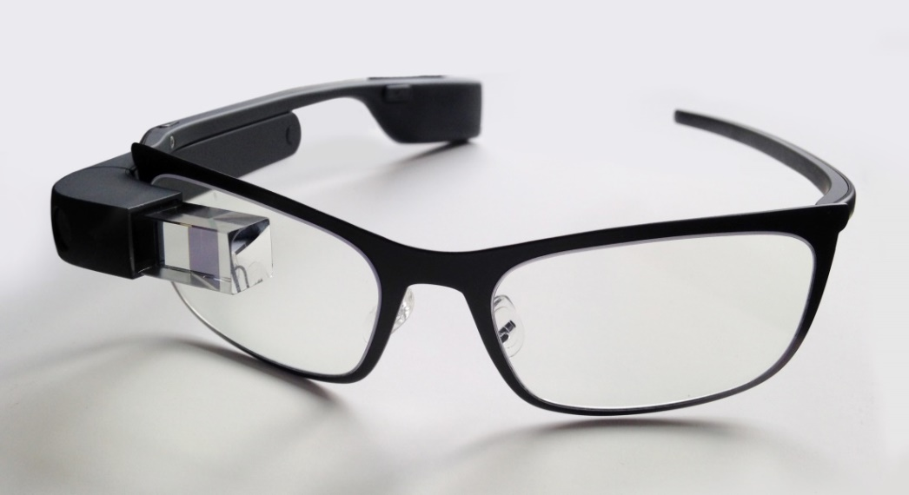

Figure 2.1 Google Glass

# 

# 3. What is Google Glass?

#### The Google glass is a glass with a smartphone in it and it brings together the world of internet and the real world. The Google glass consists of a microphone, a camera, and a screen.

## 3.1 Google glass consists of four generations:

### **First generation:**

#### Google has revealed a "[one-time optional swap out](https://support.google.com/glass/answer/3501111?hl=en)" program for the first-generation Google Glass, giving owners the option to upgrade, free of charge, to the new model, by sending their older one back. The program was introduced following the release of the new Glass Explorer Edition.

#### In this generation the use of television camera named as “analysis of glass” camera is located in the eye which will affect the eye for few hours in case of display integration.

## **Second generation:**

#### The biggest change to the second-gen Google Glass Enterprise Edition is a USB-C port for charging, replacing the magnetic cable used on the other versions of Glass. It’s a shift that makes sense considering that Google intends for these devices to be used on factory floors and warehouses where the ability to quickly recharge something is more important than the aesthetics of a magnetic charger.

#### The second generation is used to define the effect of camera.

* **Figure:**

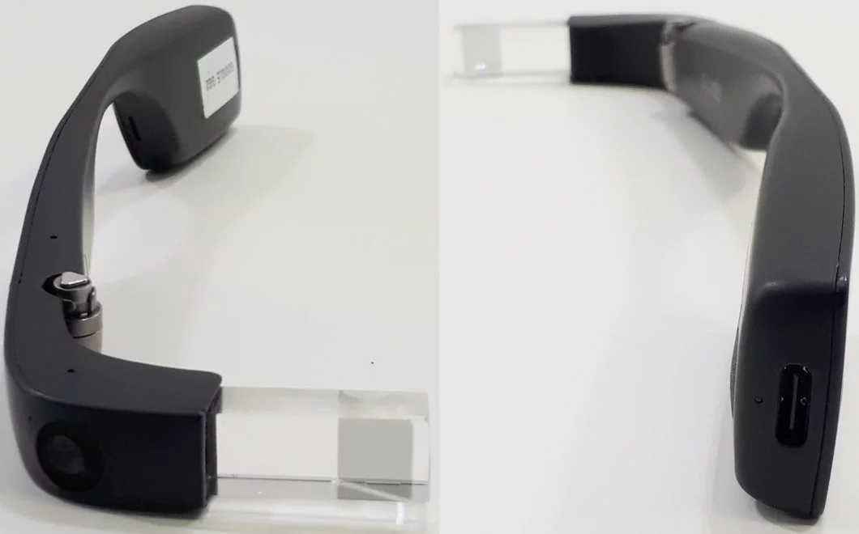

Figure 3.1 **Second generations of Google glass**

### **Third generation:**

#### The 3rd-gen Glass is as light as ever, weighing as little as a pair of regular glasses. There’s a catch though the battery life will reportedly suffer as a result of the light build. In fact, battery life is so low that users may only get 30 minutes of use in between charges.

#### The shift of attention away from battery life is a pretty big change. The first generation of Google Glass had a 780mAh battery, while the second generation stepped things up to 820mAh battery. Both of these devices offered at least a few hours of normal use.

#### This generation includes the control mechanism of focus in glass.

### **Fourth generation:**

#### In fourth generation to define looks distance of object is some of the problem can be solve in fourth generation to use the laser light to adjust the camera exactly in eye is also called as glass eye. It defines the two features virtual reality and augmented reality.

#### The problem which arises in focusing the lens is solved in this generation.

# 4. Features

## 4.1 Virtual Reality

#### The virtual reality is defined as an artificial environment to develop the software user’s real thing of real world. It is mostly used in the field of education and training to experienced senses of vision and sound.

* **Figure:**

#### Image result for virtual reality

Figure 4.1 **Virtual Reality of Google glass**

## 4.2 Augmented Reality

#### It defines the direct or indirect living things on real world environment.

#### This technology is also used for sound, video, graphic and internet data of navigation to global positioning of system.

#### It is easy to handle and a useful technology that is used by all kinds of people. It is mainly used for the purpose of navigation, social and networking purposes

* 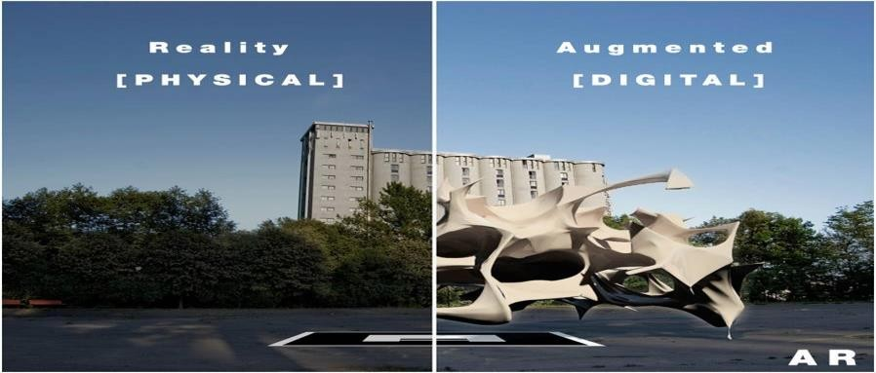 **Figure:**

Figure 2.2 Augmented Reality **of Google glass**

## 4.3 Display

#### The Google glass utilizes a liquid crystal display, field successive colour framework, LED illuminated display. The board mirrors the light and adjusts to polarization at dynamic pixel sensor sites. The in-coupling PBS then reflects the S-polarized areas of light at 45 degree through the out- coupling beam splitter which reflects the collimated light another 45 degree and into the wearer’s eye.

#### The Explorer version of Google Glass uses a [liquid crystal on silicon](https://en.wikipedia.org/wiki/Liquid_crystal_on_silicon) [field-sequential colour system](https://en.wikipedia.org/wiki/Field-sequential_color_system), [LED](https://en.wikipedia.org/wiki/Light-emitting_diode) illuminated display. The display's LED illumination is first [P-polarized](https://en.wikipedia.org/wiki/Polarization_(waves)#s_and_p_designations) and then shines through the in-coupling [polarizing beam splitter](https://en.wikipedia.org/wiki/Polarizing_beam_splitter) (PBS) to the LCOS panel. The panel reflects the light and alters it to S-polarization at [active pixel sensor](https://en.wikipedia.org/wiki/Active_pixel_sensor) sites.

#### The in-coupling PBS then reflects the S-polarized areas of light at 45° through the out-coupling beam splitter to a [collimating reflector](https://en.wikipedia.org/wiki/Collimator) at the other end. Finally, the out-coupling beam splitter (which is a partially reflecting mirror, not a polarizing beam splitter) reflects the collimated light another 45° and into the wearer's eye.

## 4.4 Camera

#### Google glass can take photographs and record videos.

#### Google Glass has the ability to take 5 MP photos and record 720p HD video. Glass Enterprise Edition 2 has an improved 8MP 80° FOV camera.

* **Figure:**

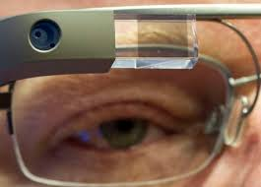

Figure 4.4 Camera **of Google glass**

## 4.5 Touch Pad

#### A touchpad is situated in favour of Google glass, which enables clients to control the gadget by swiping through a course of events like interface showed on the screen.

#### A touchpad is located on the side of Google Glass, allowing users to control the device by swiping through a timeline-like interface displayed on the screen. Sliding backward shows current events, such as weather, and sliding forward shows past events, such as phone calls, photos, etc.

* **Figure:**

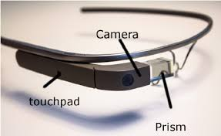

Figure 4.5 Touch **Pad of Google glass.**

# 

# 5. Technologies used in google glass

## 5.1 [Wearable Computing:](http://www.media.mit.edu/wearables/lizzy/timeline.html)

#### Wearable computers, also known as body-borne computers are small electronic devices that are worn by the bearer under, with or on top of clothing. This class of wearable technology has been developed for general or special purpose information technologies and media development.

#### Wearable computers are especially useful for applications that require more complex computational support than just hardware coded logics. One of the main features of a wearable computer is consistency. There is a constant interaction between the computer and user, i.e. there is no need to turn the device on or off.

#### Another feature is the ability to multi-task. It is not necessary to stop what you are doing to use the device; it is augmented into all other actions. These devices can be incorporated by the user to act like a prosthetic. It can therefore be an extension of the user’s mind and/or body.

* **Figure:**

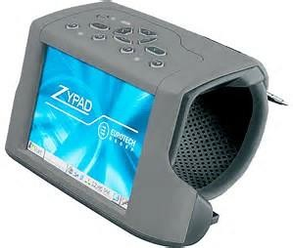

Figure 5.1 Wearable Computing.

## 5.2 Ambient Intelligence (AMI):

#### Ambient Intelligence (AMI) refers to electronic environments that are sensitive and responsive to the presence of people. Ambient intelligence is a vision on the future of consumer electronics, telecommunications and computing.

#### In an ambient intelligence world, devices work in concert to support people in carrying out their everyday life activities, tasks and rituals in easy, natural way using information and intelligence that is hidden in the network connecting these devices.

#### As these devices grow smaller, more connected and more integrated in tour environment, the technology disappears into our surroundings until only the user interface remains perceivable by users.

* **Figure:**

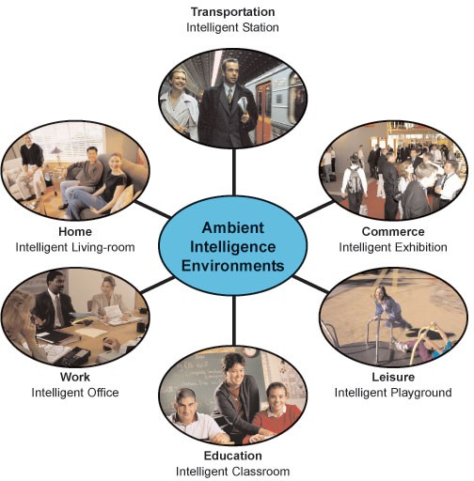

Figure 5.2 Ambient Intelligence.

## 5.3 Smart clothing:

#### Smart clothing is the next generation of apparel. It is a combination of new fabric technology and digital technology, which means that the clothing is made with new signal-transfer fabric technology installed with digital devices.

#### Since this smart clothing is still under development, many problems have occurred due to the absence of the standardization of technology.

#### Therefore, the efficiency of technology development can be strengthened through industrial standardization. This study consists of three phases. The first phase is selecting.

#### Standardization factors to propose a standardization road map. The second phase is to research and collect related test evaluation methods of smart clothing.

#### For this, we selected two categories, which are clothing and electricity/electron properties. The third phase is establishing a standardization road map for smart clothing.

#### In this study, test evaluations have not yet been conducted and proved. However, this study shows how to approach standardization. We expect that it will be valuable for developing smart clothing technology and standardization in the future.

* **Figure:**

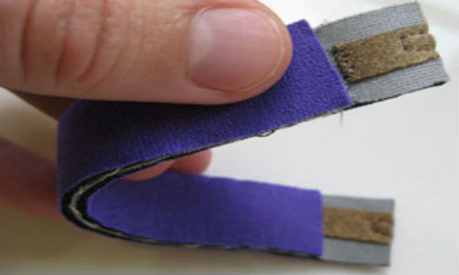

Figure 5.3 Smart clothing.

## 5.4 Eye Tap Technology:

#### An Eye Tap is a device that is worn in front of the eye that acts as a camera to record the scene available to the eye as well as a display to superimpose a computer-generate damagers on the original scene available to the eye.

#### This structure allows the user's eye to operate as both a monitor and a camera as the Eye Tap intakes the world around it and augments the image the user sees allowing it to overlay computer-generated data over top of the normal world the user would perceive.

* The Eye Tap is a hard technology to categorize under the three main headers for wearable computing (Constancy, Augmentation, and Mediation) for while it is in theory a constancy technology in nature it also has the ability to augment and mediate the reality the user perceives.

## Figure

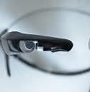

**Figure 5.4 Eye Tap Technologies.**

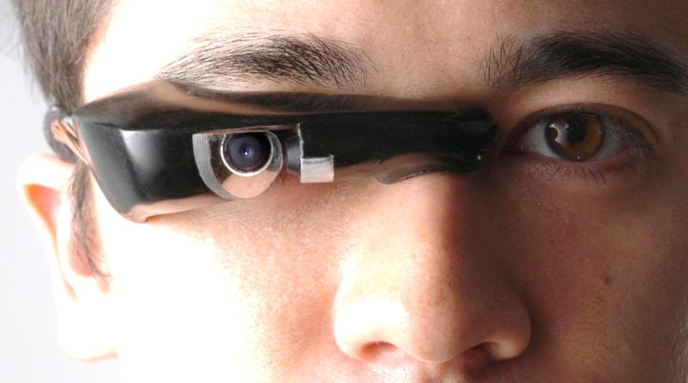

## 5.5 Smart Grid Technology:

#### A smart grid is an electrical grid that uses information and communications technology together and acts on information, such as information about the behaviours of suppliers and consumers, in an automated fashion to improve the efficiency, reliability, economics, and sustainability of the production and distribution of electricity.

* **Figure:**

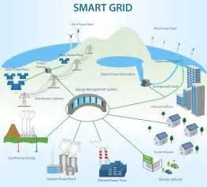

Figure 5.5 Smart Grid Technology.

## 5.6 4G Technology:

#### 4G is the fourth generation of cell phone mobile communications standards. It is successor of the third generation (3G) standards. A 4G system provides mobile ultra- broadband Internet access, for example to laptops with USB wireless modems, to smartphones, and to other mobile devices.

* **Figure:**

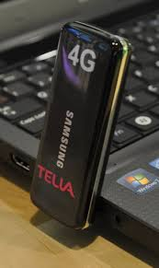

**Figure 5.6 4G Technology.**

## 5.7 Android Operating System:

#### Android is a Linux- based operating system for mobile devices such as smart phones and tablet computers, developed by Google in conjunction with the Open Handset Alliance.

#### Android is open source and Google releases the code under the Apache License. This open source code and permissive licensing allows the software to be freely modified and distributed by device manufacturers, wireless carriers and enthusiast developers.

#### Additionally, Android has a large community of developers writing applications ("apps") that extend the functionality of devices, written primarily in a customized version of the Java programming language.

#### In October 2012, there were approximately 700,000 apps available for Android, and the estimated number of applications downloaded from Google Play, Android's primary app store, was 25 billion.

* **Figure:**

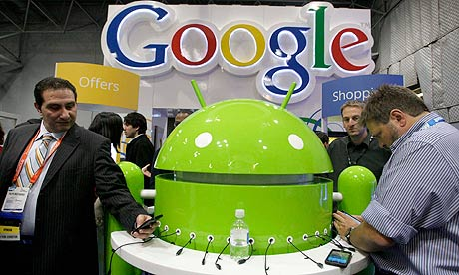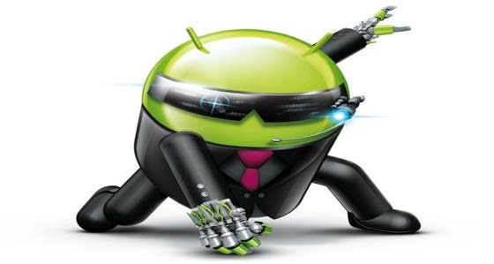

**Figure 5.5 Android Operating System.**

# 

# 6. How Does it Works?

## 6.1 Video Display:

#### Its features with the small video display that is used to display the pop up hands free information

* **Figure:**

## video display.JPG

**Figure 6.1 Video Display** of Google glass**.**

## 6.2 Camera:

* It also has the front facing 5 megapixel video camera which helps to take photos and videos in a glimpse.
* **Figure:**

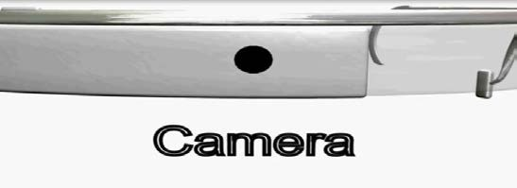

**Figure 6.2 Camera** of Google glass.

## 6.3 Speaker:

#### Google glasses are designed to be hands free wearable device that can be used to make or receive calls too. So a speaker is also designed by the ear.

* **Figure:**

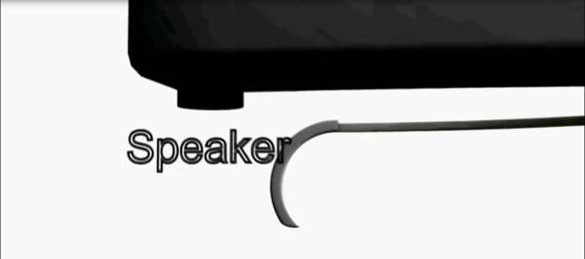

**Figure 6.3 Speaker** of Google glass**.**

## 6.4 Button:

#### A button is given at one side of the frame which helps the glass to work with the physical touch input.

* **Figure:**

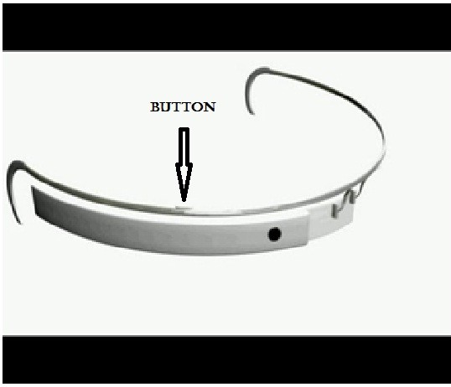

**Figure 6.4 Button** of Google glass.

## 6.5 Microphone:

#### A microphone is also put in, that can take the voice commands of the wearer of user. This microphone is also used for having telephonic communication.

#### The device will probably communicate with mobile phones through Wi-Fi and display contents on the video screen as well as respond to the voice commands of the user.

#### Google put together a short video demonstrating the features and apps of Google glasses. It mainly concentrates on the social networking, navigation and communication.

#### The video camera senses the environment and recognizes the objects and people around. The whole working of the Google glasses depends upon the user voice commands itself.

## Figure:

**Figure 6.5 Microphone** of Google glass.

# 7. Google glass architecture

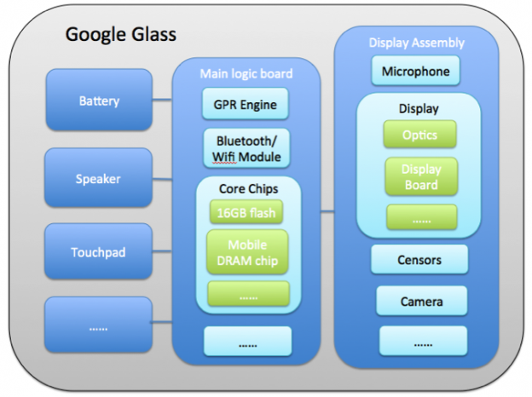

# Figure 7.1 Google glass architecture.

Architecture indicates that what modules will be part of the system, and what their roles will be (Baldwin & Clark, 2000). Google Glass is not a single-tiered system that directly formed by evenly distributed small units. By looking closer to Google Glass, we found that it is made up of many assembles that are relatively independent. On the first level of hardware teardown, we found it involves these basic assemblies: main logic board, display assembly, battery, speaker, touchpad, etc. These assemblies are themselves technologies, whose functions are distinguished from the adjacent assemblies.

We can easily find that most of these assemblies are not just created for Google Glass. Almost all of them have existed around us widely for a long time. The microphone is produced by Wolfsan, which has been equipped into smart phone; The touchpad is produced by Synaptic, which is similar to the touchpads for laptop computers; On the main logic board, the Wi-Fi/Bluetooth Modules are ordinary modules that supplied by Universal Scientific Industrial Corp. If we go further to see into core chips, there is also nothing novel. For example, ROM is provided by SanDisk, RAM is provided by Elide Memory, as many other digital devices.

However, the display assembly is one exception that looks novel to me. I continue to open up this part. This assembly is also combined with more subassemblies, creating a recursive structure from the macroscopic levels to microscopic levels. I found the gyro censors, the gravity censors and accelerometers that supplied by Intenseness Inc., and the light sensor, supplied by LITE-ON IT. They are all mature fittings that exist in the market for a long time.

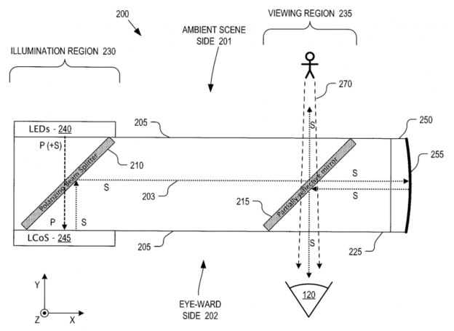

# Figure 7.2 Google glass architecture.

The most unique part in display assembly is the head-mounted display(OHMD), which uses a PBS. PBS is a partially reflecting mirror beam splitter. It allows the information displayed on LEDs be reflected to a partially reflective mirror. Through this mirror, users can see the real scene and the computer-generated information at the same time. A very similar technology called head-up display (HUD) has been developed in the field of military for a long time. Similar optical device can even be traced back before World War II. Now this technology is becoming common with aircraft and several business jets to present to the pilot a picture that overlays the outside world (Norris, Homes, Wagner, &  Forbes Smith, 2005). The most similar use of OHMD to Google Glass is the I Optic, which is developed by US Department of Defence. These two organizations cooperated to successfully make the OHMD into a very small size.

# 8. Working

#### Google Glass will communicate with other mobile phones via Wi-Fi or Bluetooth and display contents on the video screen and respond to the voice commands of the user.

#### The video camera is sensible to the environment and it recognizes objects and people around. Most of the working of the Glass depends on user’s voice commands.

* **Figure:**

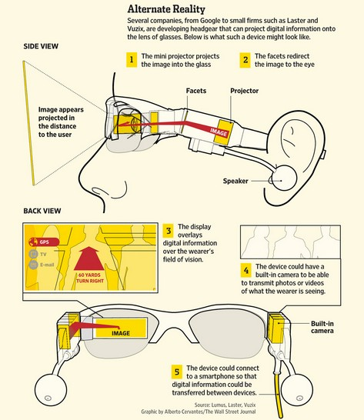

# Figure 8.1 Overall working of Google glass.

#### Google Glass has the basic features of any computer, such as a CPU, also sensors like GPS, speakers, microphone and battery, a tiny projector and a prism that directs the light to your retina. All components are neatly embedded in its frame. Most of the processing will actually take place in the cloud so that the device will be as light as possible, also a good mobile broadband signal is essential.

* **Figure:**

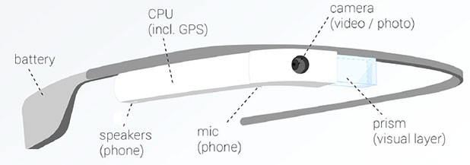

**Figure 8.2 Components of Google Glass**

#### The image below shows hoe the projector and prism in the Google Glass work together. Basically, Google Glass is just a tiny projector connected to a pair of glasses having frames with some tiny computing components.

* **Figure:**

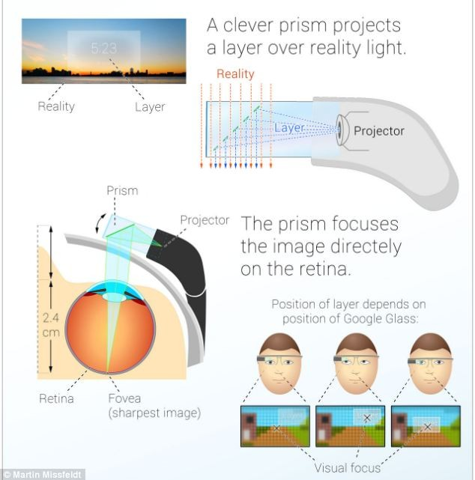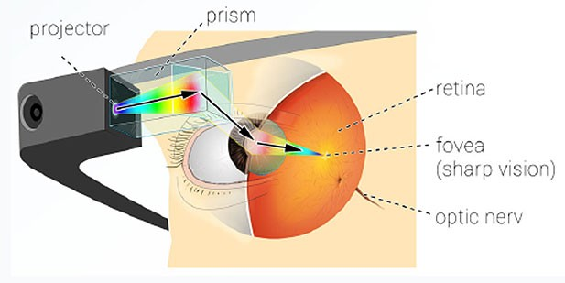

**Figure 8.3 Glass is focused so the image always appears.**

#### The image, in spite of being super-duper close to your peppers, it is bright and clear. And it is slightly transparent, so you can place it right in front of your eyes comfortably.

# 

# 9. Application

#### Google glass is built by third party developers. Some of the Google glass applications that can be mentioned are Google now, Google maps, Google+ and the Gmail. It also includes some of the applications such as facial recognition, manipulating the photos, exercise, translation, and sharing the information’s through some of the social networks such as twitter and Facebook which is being popular in this generation. On march 2013, Google released the mirror API (APPLICATION PROGRAMMING INTERFACE) which

#### Allows developers to start making apps for Google glass. On the same year Google announced the release of seven new programs that includes ever note, fashion news from ell, and news alerts from CNN. It is to be noted that a store named as a ”GLASS BOUTIQUE” allows synchronization to glass of glassware and application programming kit.

## My Glass

#### My Glass is an app that is offered by Google regarding android and its application.

## Voice Activation

#### Google glass can be controlled by voice actions rather that touchpads. To activate the Google glass the users have to turn their head to 30degree upward. Another way of activating the Google glass is tap the touchpad and just say “OK GLASS”. By saying the command glass is activated and users can start to do their actions such as taking a picture or recording a video.

* **Figure:**

#### Image result for voice activation

**Figure 9.1 Voice Activation**

* **Industry:**
* Inspections, repairs & maintenance in the (technical) industry. Being able to consult checklists or information in manuals can be important features.
* **Education:**
* Google Glass can play a big role in electronic learning.
* **Public services:**
* Police and firemen experiment with Google Glass in the US and Europe. With the device they have the right information in crisis situations where any second can be important.
* **Media:**
* Live coverage by journalists in the field. Google Glass as a hands free camera.
* **Market research:**
* Mystery shopping, qualitative research and monitoring the actual behaviour of consumers.

# 10. USES OF GOOGLE GLASS

## 10.1 Health Care Applications:

#### Dacono, California is based on e-medical record company and has developed a new application for the device which is named as “wearable health record”. This app is used to record a consultation with complete permission of patients. In the electronic medical record the patients videos, notes, photos are stored based on the cloud storage technique and collaboration service and it can be shared with the patient on request whenever the details are needed for the patient in order to commit in other hospitals or some other medical improvements.

#### In san Francisco the “robust” application is developed for wearable device which allows especially for physicians to live stream the patients visit and it will eliminate the electronic health record pain points, which saves up to 15

#### hours in a week and improves the quality of chart. This stream information can be passed to remote subscribes to secure rooms in which the doctor patient interaction allow the physicians to focus on the patients by eliminating the technologies which is being interruptive.

#### The use of Google glass to acquire images of a patient’s retina named as “GLASS FUNDOSCOPY”) is a technique on the cover of journal for mobile technology in medicine.

* **Figure:**

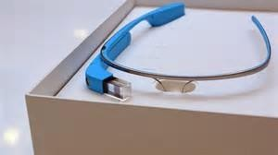

**Figure 10.1 Health Care Applications.**

## 10.2 Journalism and Mass Media Applications:

#### A web project named as “VOA & GOOGLE GLASS” explored a technology’s potential uses in journalism. This series of news stories examines the technology live reporting applications, which includes conducting interviews and covering stories from the point of reporter’s view. Another term called as “GLASS JOURNALISM” which explores the device’s application in journalism.

## 10.3 Military:

#### Google glass is being currently used by army people which is used to track the various animals and birds in the jungle and it is the first device to use in military.

## 10.4 Sports:

#### In international Olympics committee they took Google glass to the youth Olympic games and put them on a number of athletes from different disciplines to explore novel point of view in case of filmmaking.

* **Figure:**

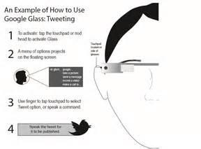

**Figure 10.4 Sports of Google Glass.**

# 

# 11. Google Glass Design Principles

#### Here are the key guidelines for designing a good Google Glass experience. Straight from Timothy Jordan, Senior Developer Advocate at Google.

#### Design for Glass and it’s unique interface

#### Don’t get in the way or be intrusive (no intermodal dialogues)

#### Keep it timely. Glass is a “right now” device.

#### Avoid the unexpected. Don’t surprise the users with unexpected communications or time cards.

# 

# 12. Future Scope

#### Google Glass is as futuristic a gadget we’ve seen in recent times. It’s limited in scope right now, but the future, Google believes, is bright and the device itself is “incredibly compelling”.

#### Google is trying their hardest to push the Project Glass through the FCC this year. Reports show that Google is trying to get the approval by the FCC this year but there are already several hundred glasses made for testing internally.

# 

# 13. Advantages of Google Glass

#### Easy to wear and use.

#### Glass is sleek, light and easily wearable and you won’t require keeping it on and off your pockets, like mobile phones.

#### No Bluetooth or camera needed when Glass is on, it’ll do all for you.

#### Glass will provide you detailed information and satisfactory results on your queries.

#### Make phone calls, SMS, emails though Google Glass, no Smartphone required.

#### Keep your calendar events, information, contacts updated on Glass.

#### Easier navigation and maps will be provided through Glass.

#### Glass will make you look hi-tech and updated on technology and create an impressive impact on people.

# 

# 14. Disadvantages of Google Glass

#### Glass might give you a ‘nerdy’ look that might create clumsiness among people.

#### No indication while clicking pictures (like pointing the camera) which almost sounds like a hidden camera trying to capture a non-ready subject.

#### Chances are there to drop yourself down in the road while reading a text or email since you can’t get your eyes off it.

#### No public privacy concern so the worry of leaking out information still remains.

#### Competition is on pace. The future might bring a contact lens version of Glass after which Google Glass is supposed to sink.

# 

# 15. Conclusion

#### Although there are many barriers and problems Google still needs to work through before finalizing the consumer version of Glass, the potential benefits make Glass a project worth perusing.

#### It is Lee’s expectations “expectation that in three to five years it will actually look unusual and awkward when we view someone holding an object in their hand and looking down at it.

#### Wearable computing will become the norm” (Levy, 2012). With all the wonderfully accessible features and endless potential for applications, it just might catch on.

# 16. References

#### [www.wikipedia.com](http://www.wikipedia.com/)

#### [www.studymafia.org](http://www.studymafia.org/)

PPT

